Classification 2: Vertebrate Grab Bag Name

Worksheet 1 Date

Period

Directions: Using the words in the “grab bag,” match the correct characteristics with the correct vertebrate group. Each group will have six characteristics, one set of examples, and a class name. Each clue may be used only once unless stated otherwise on the clue.

Examples:

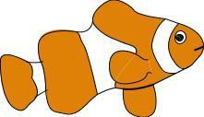

Examples:

Examples:

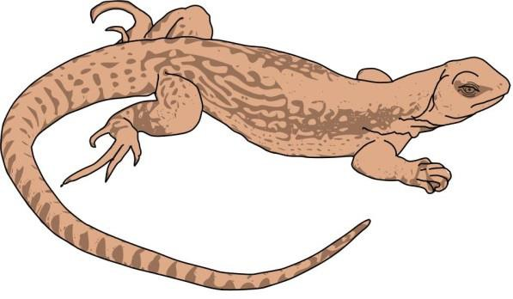

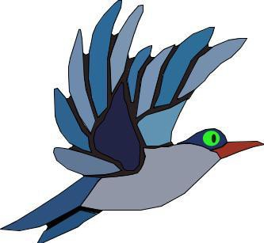
Examples:

Examples:

